**CRON (Enhancement)**

**Functionality:**

* Cron app is actually used to generate an event based on the time interval which we provide in the form of a cron expression.
* When a workflow event is associated with the cron expression and published, an event occurs for every time interval we specified.
* For example, if we provide the expression as **0 * * ? * \***(for ref. <https://crontab.guru/>) then event gets triggered for every one minute.
* No.of execution times is another feature that is added which actually defines how many times event should execute.

**Technical Details:**

Schedule CRON job with different expressions for performing an action in the scheduled time intervals.  
  
W1 (Schedule Cron):  
This workflow should send a mail with day and time with below different trigger expressions  
  
Trigger Expression 1 - Minute - 0 * * ? * *

**Screenshot Link:**

[**https://i.imgur.com/9ErVYmn.png**](https://i.imgur.com/9ErVYmn.png)

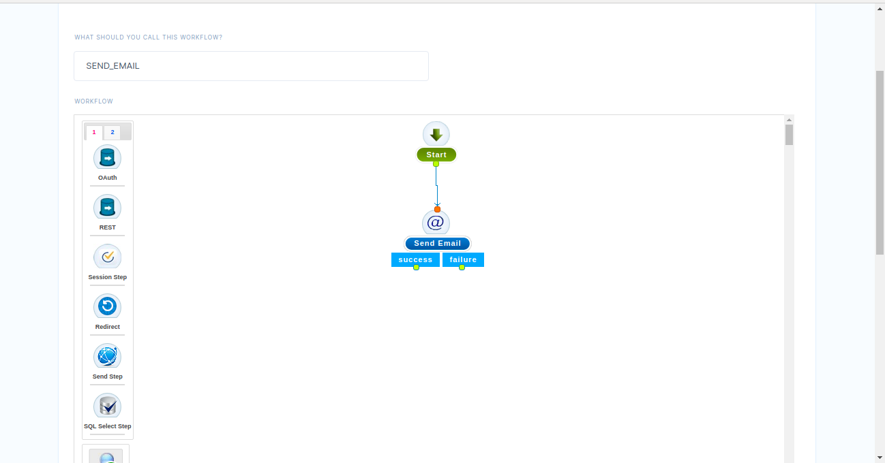

<https://snag.gy/OmMjIH.jpg>

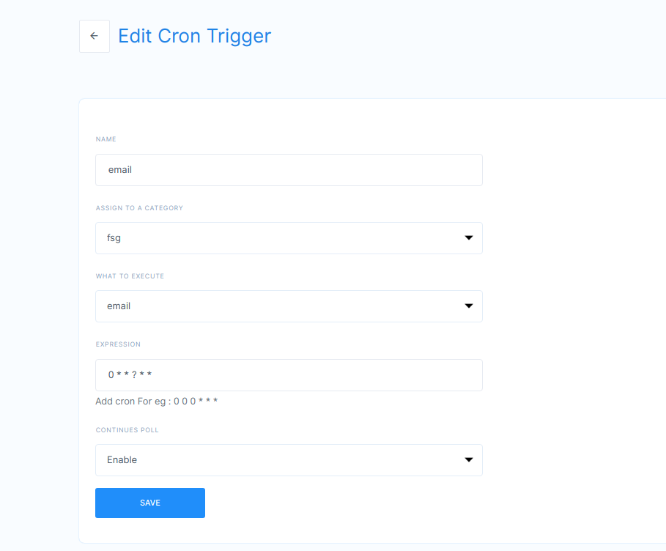

Once hit the published url it will send mail for every one minute.

Number of execution times is tested through testcron table in reports schema from mysql workbench.

Screenshot

<https://snag.gy/T8sdjR.jpg>

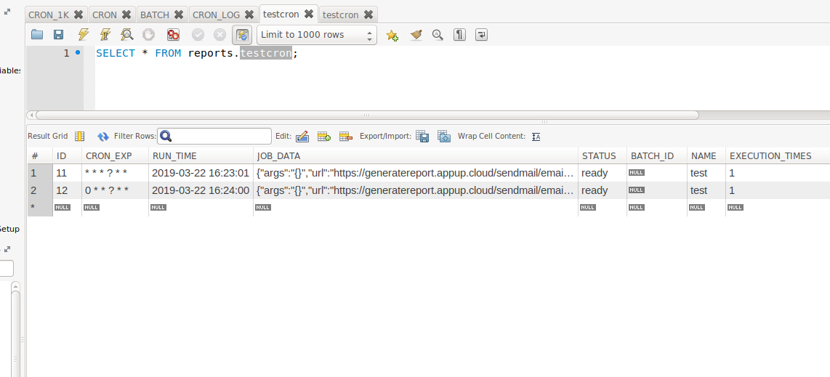

In the above screen shot.

1. ID - auto generation key
2. CRON_EXP - cron expression for time intervals.
3. RUN_TIME - Runtime is the server run time. Once we enable the cron expression runtime will be updated. Initially runtime will be empty.
4. JOB_DATA - In job data we pass publishes url, method type and email address.{"args":"{}","url":"[https://generatereport.appup.cloud/sendmail/email","method":"post","form":"{email:saradavani.42@gmail.com}","headers](https://generatereport.appup.cloud/sendmail/email%22,%22method%22:%22post%22,%22form%22:%22%7Bemail:saradavani.42@gmail.com%7D%22,%22headers)":"{}"}
5. STATUS - Initially STATUS is NULL.Ready - Once RUN_TIME is updated then STATUS is changed to ready

Inprogress - If RUN_TIME is less than CURRENT_TIME then the status will be in progress.

Locked -

Done - once the mail sent to the respective email then the status changes to done.

1. BATCH_ID
2. NAME
3. EXECUTION_TIME - Here we will set number of execution times for cron jobs.

Example: EXECUTION_TIME - 4 and CRON_EXP - 0 */10 * ? * *

It will send four emails for every 10 minutes time interval.

Credentials:

Url : <https://our.appup.com/#/home/cloud>

Username /password : [v56@yopmail.com](mailto:v56@yopmail.com) / 123456

Cloud / App : 58 /cron